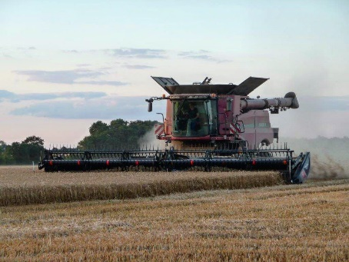
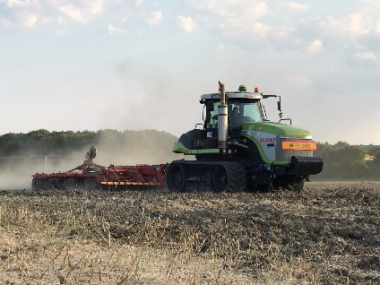

Harvest work opportunity
Bithia Ltd. are looking for two harvest workers to help throughout the harvest period. Bithia Ltd. is a large arable farming business which farm just over 1000HA in mid-Norfolk. Bithia Ltd.’s current cropping includes Milling wheat, feed, malting Barley, WOSR, award winning Marrowfat peas and Red Fescue grass seed. The farm is ring fenced within two units; the main farm Saham Grove being approx.800HA and Lawrence farm 260HA.
We are currently running Case Pumas, two JCB loaders, a Bateman sprayer, Case combine with a 35ft Mac Don header. We also hire in Challengers and an extra Case Puma for cultivation and drilling.
Job roles and descriptions:
We will be requiring two students for this coming harvest 2021 from the beginning of July (however this can be a flexible date.) This role would last until the end of harvest with the possibility of cultivations and drilling.
Operations to include but not limited to (depending on experience and ability) relief combine driving, corn carting, secondary cultivation’s with the opportunity to gain more experience and skills for the right candidates.
We do require our students to have a clean Full UK car driving license. A loader ticket and combine experience would be desirable but is not required. The job will entail long hours and weekend work.
Accommodation and farm vehicle available, when working long days an weekends hot meals are also provided.
If you are interested please send a CV and cover note to Mr Toby Lowe the farm manager via email to tobylowe@bithia.co.uk.
If you need any more information or have any questions please feel free to email or call on 07387163940.

